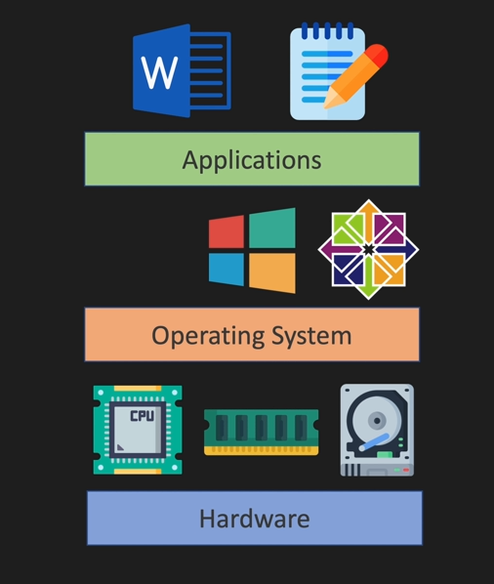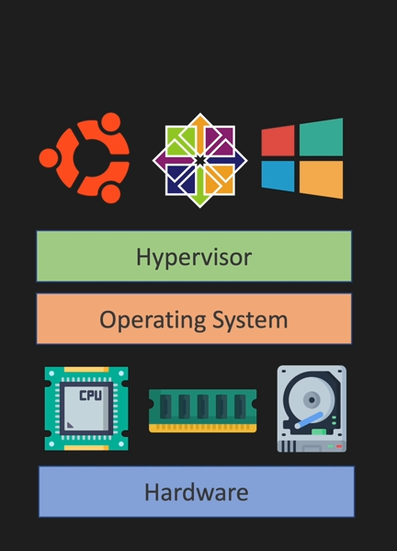

Basic Commands
Uptime – shows u how much your server is up
Hostname – shows the hostname
Pwd – Print Working Directory
Ls – List files in a directory
ls –l – List directory with more properties
Ls –la – Show All files + Hidden Files
Alias – Used to replace commands e.g alias stanley = pwd
Unalias – to remove
Show all Aliases – alias
History – shows a list of all the commands we have used
Type command – shows if it’s internal or external
which command – shows location of the command
ls - - help – For help
ls –r – Reverse
man command name – Explanation of a command and usage ( You don’t have to cram Commands)
env – Shows Variable Paths

